The NC TIDE Empowering Hope Award will be awarded to an individual who has overcome adversity through tenacity, strength, and self-determination while inspiring hope and empowering others through their own personal life journey. If you feel you have an individual who would qualify and would like to be recognized, please complete the attached application form.
The individual identified as the 2024 recipient will be recognized at the NC TIDE 2024 Conference in Wilmington, NC on 4/22/2024 prior to the Opening Plenary Session.
NC TIDE Empowering Hope Award- Recognition of a member who has overcome adversity through tenacity, strength, and self-determination while inspiring hope and empowering others through their own personal life journey.

Mark Your Calendar! NC TIDE 2024 Conference, April 22-24, 2024
Hotel Ballast (Formerly Hilton Riverside)
301 N. Water Street
More Info: www.nctide.org
Empowering Hope Award Application:

Directions: Please complete the information below to the best of your ability. All applications will be reviewed by a panel and the member identified as the 2024 recipient will be recognized at the NC TIDE 2024 Conference in Wilmington, NC on 4/22/2024. All applications must be received by 3/20/2024 for consideration.

Nominee/Member Name:
MCO Affiliation:
Provider/MCO Sponsor:
Why this person should receive the 2024 NC TIDE Empowering Hope Award? Please review our description of the award and describe how your nominee fits the award. (250-300 words)

Nominated By:
E-Mail Address:
Phone #:
Affiliation to Nominee:

Reminder Note to Provider/MCO Staff: Please remember to complete and submit the attached Release of Information Form when submitting your completed application.
Submit your application to: contactus@nctide.org

AUTHORIZATION TO RELEASE INFORMATION

To Permit Use and Disclosure of Health Information
This authorization form implements the requirements for consumer authorization to use and disclose Health Information protected by the Federal Health Privacy Law, 45 C.F.R. parts 160 and 164; The federal Confidentiality law, 42 C.F.R. part 2, and State Confidentiality Law governing Mental Health, Developmental Disabilities, and Substance Abuse Services G.S. 122C.

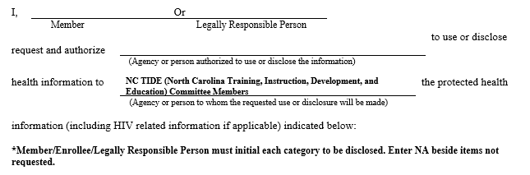
Member/Enrollee______________________________ Date of Birth__________________________
XX Other: NC TIDE Empowering Hope Application
Purpose of Disclosure: XX Other: Application for NC TIDE Empowering Hope Award Recipient

I understand that the information to be released may include information regarding HIV or AIDS status, drug abuse, alcohol abuse, or psychological or psychiatric impairments.

Once information is disclosed pursuant to this signed authorization, I understand that the federal health privacy law (45 C.F.R. Part 164) protecting health information may not apply to the recipient of the information and therefore, may not prohibit the recipient from redisclosing it. Other laws, however, may prohibit redisclosure. When this agency discloses mental health and developmental disabilities information protected by state law (G.S. 122C) or substance abuse treatment information protected by federal law (42 C.F.R. Part 2), we must inform the recipient of the information that redisclosure is prohibited except as permitted or required by these two laws. Our Notice of Privacy Practices describes the circumstances where disclosure is permitted or required by these laws.
I understand that, with certain exceptions, I have the right to revoke this authorization at any time. If I want to revoke this authorization, I must do so in writing by giving the written notice of revocation to NCTIDE by delivering the written notice to the NC TIDE President at 514 E Main Street, Beulaville NC 28518. I understand that my revocation will not affect any actions taken by NC TIDE before receiving this notice of revocation. If not revoked earlier, this authorization expires one year from the date it is signed.
I understand that I may refuse to sign this authorization form. If I choose not to sign this form, I understand that my application will not be submitted and reviewed for the NC TIDE Empowering Hope Award.
I understand that if I am the recipient of the NC TIDE Empowering Hope award, my application will be shared at the annual conference as the award winner and I will be acknowledged in public at the conference.
Member/Enrollee ______________________________ or Legally Responsible Person ____________________________
Date_______________________ Expiration Date of Authorization__________________________

